**1.1. Baze de date**

Databases and database systems are an essential component of life in modern society: most of us encounter several activities every day that involve some interaction with a database. For example, if we go to the bank to deposit or withdraw funds, if we make a hotel or airline reservation, if we access a computerized library catalog to search for a bibliographic item, or if we purchase something online—such as a book, toy, or computer; chances are that our activities will involve someone or some computer program accessing a database. Even purchasing items at a supermarket often automatically updates the database that holds the inventory of grocery items.

A **database** is a collection of related data.1 By **data**,we mean known facts that can be recorded and that have implicit meaning. For example, consider the names, telephone numbers, and addresses of the people you know. You may have recorded this data in an indexed address book or you may have stored it on a hard drive, using a personal computer and software such as Microsoft Access or Excel. This collection of related data with an implicit meaning is a database.

The preceding definition of database is quite general; for example, we may consider the collection of words that make up this page of text to be related data and hence to constitute a database. However, the common use of the term *database* is usually more restricted. A database has the following implicit properties:

- A database represents some aspect of the real world, sometimes called the **miniworld** or the **universe of discourse.** Changes to the miniworld are reflected in the database.

- A database is a logically coherent collection of data with some inherent meaning. A random assortment of data cannot correctly be referred to as a database.

- A database is designed, built, and populated with data for a specific purpose. It has an intended group of users and some preconceived applications in which these users are interested.

A database can be of any size and complexity. For example, the list of names and addresses referred to earlier may consist of only a few hundred records, each with a simple structure. On the other hand, the computerized catalog of a large library may contain half a million entries organized under different categories, by primary author’s last name, by subject, by book title, with each category organized alphabetically.

A **database management system (DBMS)** is a collection of programs that enables users to create and maintain a database. The DBMS is a *general-purpose software system* that facilitates the processes of *defining, constructing, manipulating,* and *sharing* databases among various users and applications. **Defining** a database involves specifying the data types, structures, and constraints of the data to be stored in the database. The database definition or descriptive information is also stored by the DBMS in the form of a database catalog or dictionary; it is called **meta-data**. **Constructing** the database is the process of storing the data on some storage medium that is controlled by the DBMS.**Manipulating** a database includes functions such as querying the database to retrieve specific data, updating the database to reflect changes in the miniworld, and generating reports from the data. **Sharing** a database allows multiple users and programs to access the database simultaneously.

**1.1.1. Clasificare**

Several criteria are normally used to classify DBMSs. The first is the **data model** on which the DBMS is based. The main data model used in many current commercial DBMSs is the **relational data model**. The **object data model** has been implemented in some commercial systems but has not had widespread use.Many legacy applications still run on database systems based on the **hierarchical** and **network data** **models**. Examples of hierarchical DBMSs include IMS (IBM) and some other systems like System 2K (SAS Inc.) and TDMS. IMS is still used at governmental and industrial installations, including hospitals and banks, although many of its users have converted to relational systems. The network data model was used by many vendors and the resulting products like IDMS (Cullinet—now Computer Associates), DMS 1100 (Univac—now Unisys), IMAGE (Hewlett-Packard), VAXDBMS (Digital—then Compaq and now HP), and SUPRA (Cincom) still have a following and their user groups have their own active organizations. If we add IBM’s popular VSAM file system to these, we can easily say that a reasonable percentage of worldwide-computerized data is still in these so-called **legacy database systems**.

The relational DBMSs are evolving continuously, and, in particular, have been incorporating many of the concepts that were developed in object databases. This has led to a new class of DBMSs called **object-relational DBMS**s.We can categorize DBMSs based on the data model: relational, object, object-relational, hierarchical, network, and other.

More recently, some experimental DBMSs are based on the XML (eXtended Markup Language) model, which is a tree-structured (hierarchical) data model. These have been called **native XML DBMSs.** Several commercial relational DBMSs have added XML interfaces and storage to their products.

The second criterion used to classify DBMSs is the **number of users** supported by the system. **Single-user systems** support only one user at a time and are mostly used with PCs. **Multiuser systems**, which include the majority of DBMSs, support concurrent multiple users.

The third criterion is the **number of sites** over which the database is distributed. A DBMS is **centralized** if the data is stored at a single computer site. A centralized DBMS can support multiple users, but the DBMS and the database reside totally at a single computer site. A **distributed** DBMS (DDBMS) can have the actual database and DBMS software distributed over many sites, connected by a computer network. **Homogeneous** DDBMSs use the same DBMS software at all the sites, whereas **heterogeneous** DDBMSs can use different DBMS software at each site. It is also possible to develop **middleware software** to access several autonomous preexisting databases stored under heterogeneousDBMSs. This leads to a **federated** DBMS (or **multidatabase system**), in which the participating DBMSs are loosely coupled and have a degree of local autonomy. Many DDBMSs use client-server architecture.

The fourth criterion is cost. It is difficult to propose a classification of DBMSs based on cost. Today we have open source (free) DBMS products like MySQL and PostgreSQL that are supported by third-party vendors with additional services. The main RDBMS products are available as free examination 30-day copy versions as well as personal versions, which may cost under $100 and allow a fair amount of functionality. The giant systems are being sold in modular form with components to handle distribution, replication, parallel processing,mobile capability, and so on, and with a large number of parameters that must be defined for the configuration. Furthermore, they are sold in the form of licenses—site licenses allow unlimited use of the database system with any number of copies running at the customer site. Another type of license limits the number of concurrent users or the number of user seats at a location. Standalone single user versions of some systems like Microsoft Access are sold per copy or included in the overall configuration of a desktop or laptop. In addition, data warehousing and mining features, as well as support for additional data types, are made available at extra cost. It is possible to pay millions of dollars for the installation and maintenance of large database systems annually.

We can also classify a DBMS on the basis of the **types of access path** options for storing files. One well-known family of DBMSs is based on inverted file structures. Finally, a DBMS can be **general purpose** or **special purpose**.When performance is a primary consideration, a special-purpose DBMS can be designed and built for a specific application; such a system cannot be used for other applications without major changes. Many airline reservations and telephone directory systems developed in the past are special-purpose DBMSs. These fall into the category of **online** **transaction processing** (**OLTP**) systems, which must support a large number of concurrent transactions without imposing excessive delays.

Let us briefly elaborate on the main criterion for classifying DBMSs: the data model. The basic **relational data model** represents a database as a collection of tables, where each table can be stored as a separate file. Most relational databases use the high-level query language called SQL and support a limited form of user views.

The **object data model** defines a database in terms of objects, their properties, and their operations. Objects with the same structure and behavior belong to a **class**, and classes are organized into **hierarchies** (or **acyclic graphs**). The operations of each class are specified in terms of predefined procedures called **methods**. Relational DBMSs have been extending their models to incorporate object database concepts and other capabilities; these systems are referred to as **object-relational** or **extended relational systems.**

The XML model has emerged as a standard for exchanging data over the Web, and has been used as a basis for implementing several prototype native XML systems. XML uses hierarchical tree structures. It combines database concepts with concepts from document representation models. Data is represented as elements; with the use of tags, data can be nested to create complex hierarchical structures. This model conceptually resembles the object model but uses different terminology. XML capabilities have been added to many commercial DBMS products.

The **hierarchical model** represents data as hierarchical tree structures. Each hierarchy represents a number of related records. There is no standard language for the hierarchical model. A popular hierarchical DML is DL/1 of the IMS system. It dominated the DBMS market for over 20 years between 1965 and 1985 and is still a widely used DBMS worldwide, holding a large percentage of data in governmental, health care, and banking and insurance databases. Its DML, called DL/1, was a de facto industry standard for a long time. DL/1 has commands to locate a record (e.g., GET { UNIQUE, NEXT} <record-type> WHERE <condition>). It has navigational facilities to navigate within hierarchies (e.g., GET NEXT WITHIN PARENT or GET {FIRST, NEXT} PATH <hierarchical-path-specification> WHERE <condition>). It has appropriate facilities to store and update records (e.g., INSERT <record-type>, REPLACE <record-type>). Currency issues during navigation are also handled with additional features in the language.

**1.1.2. Arhitectura unui sistem de baze de date**

The architecture of DBMS packages has evolved from the early monolithic systems, where the whole DBMS software package was one tightly integrated system, to the modern DBMS packages that are modular in design, with a client/server system architecture. This evolution mirrors the trends in computing, where large centralized mainframe computers are being replaced by hundreds of distributed workstations and personal computers connected via communications networks to various types of server machines—Web servers, database servers, file servers, application servers, and so on.

The design of a DBMS depends on its architecture. It can be centralized or decentralized or hierarchical. The architecture of a DBMS can be seen as either single tier or multi-tier. An n-tier architecture divides the whole system into related but independent **n** modules, which can be independently modified, altered, changed, or replaced.

In 1-tier architecture, the DBMS is the only entity where the user directly sits on the DBMS and uses it. Any changes done here will directly be done on the DBMS itself. It does not provide handy tools for end-users. Database designers and programmers normally prefer to use single-tier architecture.

If the architecture of DBMS is 2-tier, then it must have an application through which the DBMS can be accessed. Programmers use 2-tier architecture where they access the DBMS by means of an application. Here the application tier is entirely independent of the database in terms of operation, design, and programming.

**3-tier Architecture**

A 3-tier architecture separates its tiers from each other based on the complexity of the users and how they use the data present in the database. It is the most widely used architecture to design a DBMS.

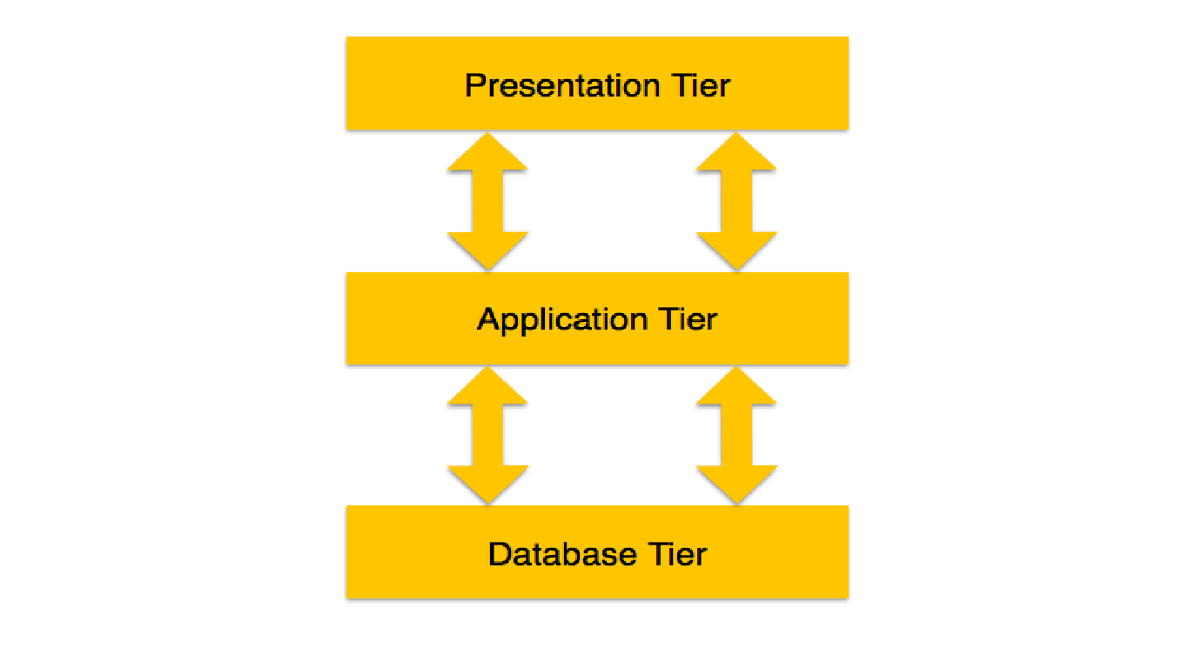

Figura 1.1

* **Database (Data) Tier** − At this tier, the database resides along with its query processing languages. We also have the relations that define the data and their constraints at this level.
* **Application (Middle) Tier** − At this tier reside the application server and the programs that access the database. For a user, this application tier presents an abstracted view of the database. End-users are unaware of any existence of the database beyond the application. At the other end, the database tier is not aware of any other user beyond the application tier. Hence, the application layer sits in the middle and acts as a mediator between the end-user and the database.
* **User (Presentation) Tier** − End-users operate on this tier and they know nothing about any existence of the database beyond this layer. At this layer, multiple views of the

database can be provided by the application. All views are generated by applications that reside in the application tier.

Multiple-tier database architecture is highly modifiable, as almost all its components are independent and can be changed independently.

**1.1.4. Funcțiile SGBD-urilor**

There are several functions that a DBMS performs to ensure data integrity and consistency of data in the database. The ten functions in the DBMS are: data dictionary management, data storage management, data transformation and presentation, security management, multiuser access control, backup and recovery management, data integrity management, database access languages and application programming interfaces, database communication interfaces, and transaction management.

**1. Data Dictionary Management**

Data Dictionary is where the DBMS stores definitions of the data elements and their relationships (metadata).  The DBMS uses this function to look up the required data component structures and relationships. When programs access data in a database they are basically going through the DBMS. This function removes structural and data dependency and provides the user with data abstraction. In turn, this makes things a lot easier on the end user. The Data Dictionary is often hidden from the user and is used by Database Administrators and Programmers.

**2. Data Storage Management**

This particular function is used for the storage of data and any related data entry forms or screen definitions, report definitions, data validation rules, procedural code, and structures that can handle video and picture formats. Users do not need to know how data is stored or manipulated. Also involved with this structure is a term called performance tuning that relates to a database’s efficiency in relation to storage and access speed.

**3. Data Transformation and Presentation**

This function exists to transform any data entered into required data structures. By using the data transformation and presentation function the DBMS can determine the difference between logical and physical data formats.

**4. Security Management**

This is one of the most important functions in the DBMS. Security management sets rules that determine specific users that are allowed to access the database. Users are given a username and password or sometimes through biometric authentication (such as a fingerprint or retina scan) but these types of authentication tend to be more costly. This function also sets restraints on what specific data any user can see or manage.

**5. Multiuser Access Control**

Data integrity and data consistency are the basis of this function. Multiuser access control is a very useful tool in a DBMS, it enables multiple users to access the database simultaneously without affecting the integrity of the database.

**6. Backup and Recovery Management**

Backup and recovery is brought to mind whenever there is potential outside threats to a database. For example if there is a power outage, recovery management is how long it takes to recover the database after the outage. Backup management refers to the data safety and integrity; for example backing up all your mp3 files on a disk.

**7.     Data Integrity Management**

The DBMS enforces these rules to reduce things such as data redundancy, which is when data is stored in more than one place unnecessarily, and maximizing data consistency, making sure database is returning correct/same answer each time for same question asked.

**8. Database Access Languages and Application Programming Interfaces**

A query language is a nonprocedural language. An example of this is SQL (structured query language). SQL is the most common query language supported by the majority of DBMS vendors. The use of this language makes it easy for user to specify what they want done without the headache of explaining how to specifically do it.

**9.  Database Communication Interfaces**

This refers to how a DBMS can accept different end user requests through different network environments. An example of this can be easily related to the internet.  A DBMS can provide access to the database using the Internet through Web Browsers (Mozilla Firefox, Internet Explorer, Netscape).

**10*.* Transaction Management**

This refers to how a DBMS must supply a method that will guarantee that all the updates in a given transaction are made or not made.All transactions must follow what is called the ACID properties.

A – Atomicity: states a transaction is an indivisible unit that is either performed as a whole and not by its parts, or not performed at all.It is the responsibility of recovery management to make sure this takes place.

C – Consistency: A transaction must alter the database from one constant state to another constant state.

I – Isolation:Transactions must be executed independently of one another.Part of a transaction in progress should not be able to be seen by another transaction.

D – Durability:A successfully completed transaction is recorded permanently in the database and must not be lost due to failures**.**